It is so weird when a wide angle photo is stretched like this in the banner, did you try cropping the top and bottom instead of stretching it to fit the frame? Or maybe you can do something like the A&E banner? Otherwise maybe we should use another photo, this looks so weird…

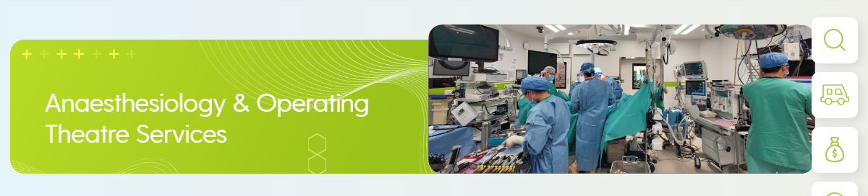

The photo of our dept on this page is still stock photo
https://kwh.9u1.net/Our-Services.html#s2

由於Banner圖片需要統一固定的尺寸, 故我們做了適當的裁剪, 但我們沒有拉動圖片使其變形,
可能是因為google drive上提供的原圖片有變形的情況出現, 我們已代為修改, 你們可以刷新看看最新效果

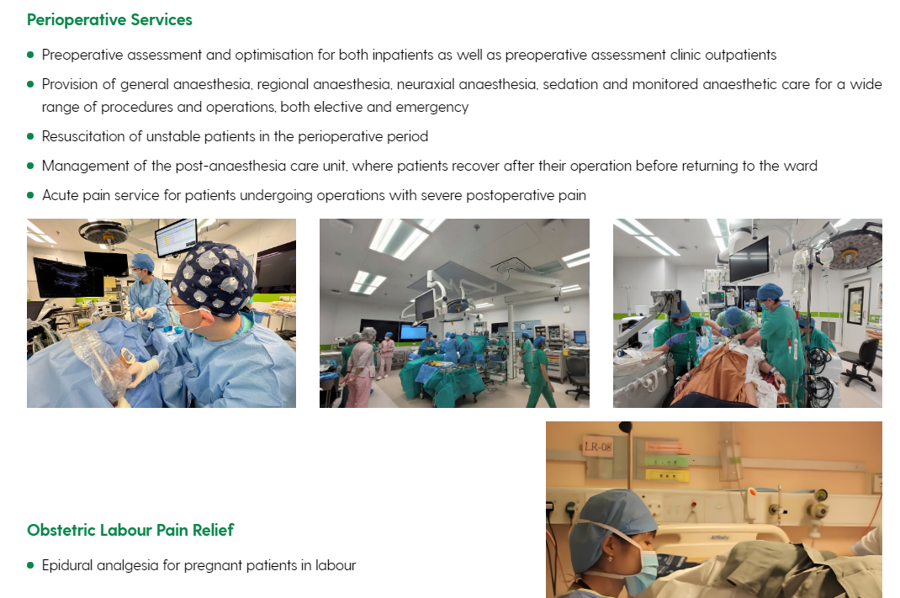

First point: please change it to “as well as clinic outpatients” and 4th point “wards”
已修改

The photo layout is also very strange, can the 3 photos be put on the side like the rest? Maybe we can move one photo to the top banner if you cannot fix it, and just put 2 on the side, can I have some demo to see how it looks?
目前網站文字與圖片的配搭有兩種處理, 一種是左字右圖, 另一種是上字下圖
現在覺得版面奇怪, 相信是因為兩種配搭同時出現
可以幫你改為統一全部左字右圖, 但是Perioperative Services的section共有5個point, 而圖片卻只有2或3張, 這樣會配搭不平衡, 導致有文字沒有配圖, 或有圖片沒有配字

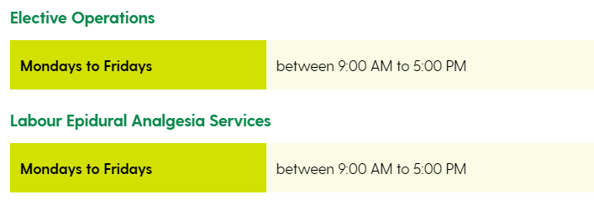
Please delete “between” for both.
已修改

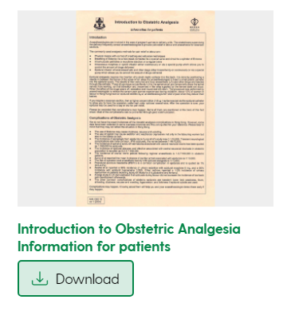
Please delete “information for patients”.
已修改

What else can be here if it is not for patients?
不明白意思

And please move “awake fibreoptic intubation” leaflet to the last leaflet.
已修改

For videos, since this is the English version, Cantonese video should not appear here (2nd video). Please move peri-operative journey one to the first, and only keep the pain video for the Chinese version of the website, and please move that video to the last one on the Chinese website.
想問清楚, 意思是英文版看到的2條影片與中文版看到的影片不同內容, 是正確的處理嗎?
例如【General Anaesthesia】影片只會出現在英文版, 而不會有一條翻譯影片名稱叫【全身麻醉】出現在中文版嗎?
現在英文版共有3條, 而中文版則顯示4條, 如有錯誤請再指示一次, 謝謝

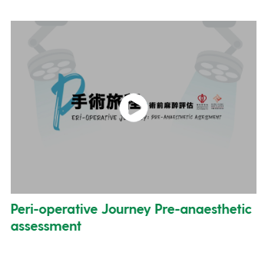
Please change this into two lines:
Peri-operative Journey
Pre-anaesthetic assessment
已修改

Because we did not take a lot of photos, please delete the dept photos section.
已修改

